**ANALYSIS OF THE THREE-ELEMENT WINDKESSEL MODEL AS A SURROGATE OF THE SYSTEMIC ARTERIAL SYSTEM, 2024-2025**

**Lucía Calatayud, 1 Iñigo Beistegui, 1 Giorgio Di Francesca 1 (Team 2)**

1Universidad de Navarra, TECNUN Escuela de Ingeniería, 20018 Donostia-San Sebastián, Spain.

# Abstract

*In this work, we demonstrate the robustness of our model in interpreting cardiovascular parameters in three different (P, Q) data pairs: one patient-specific (children -aged from 5 weeks to 2 years old-) and two additional synthetic pairs (adults). And the emphasis is on studying CO, SV and vascular resistance per pair. A 3-element Windkessel model (3-WK) was utilized to calculate the arterial pressure response to a prescribed blood flow rate (P3-WK). Assessment of the model performance by comparing simulated (P3-WK) versus measured or generated pressure (Pmeas).[2] We measure four kinds of errors: point-to-point relative error, mean pressure error, error in systolic pressure and error in diastolic pressure.*

*Furthermore, the report analyzes the effect of different value/s about 25% increasing and decreasing distal resistance (R2) on 3-WK model. This sensitivity is investigated by analyzing the effects on the simulated pressure response and cardiovascular parameters This study contributes to explain the adaptability and reproducibility of 3-WK model representing varied cardiovascular pathophysiology in both pediatric and adult populations.[4]*

# Keywords:

Windkessel model, cardiac output, stroke volume, vascular resistance, distal resistance

# INTRODUCTION

Fluid flow in the cardiovascular system is a complex, three-dimensional process, where both velocity and pressure vary across space. This complexity often requires numerical simulations for detailed analysis. However, simplified models like Frank's Windkessel model provide useful insights into cardiovascular dynamics by mimicking the load on the heart.[1]

The three-element Windkessel model, illustrated in Figure 1.1, represents the systemic arterial tree using three key parameters: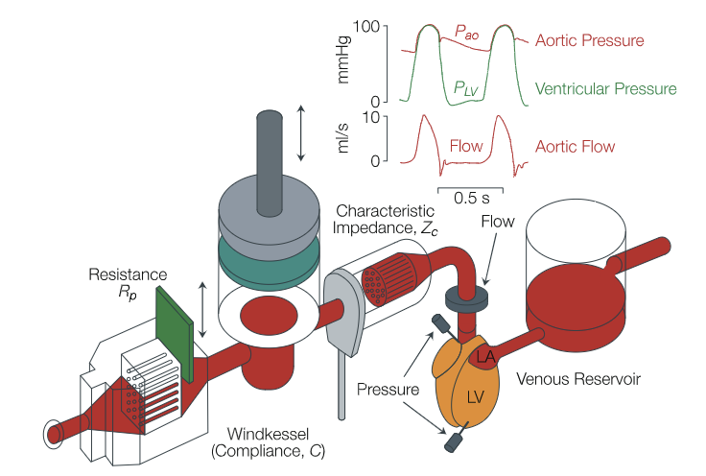

1. **Peripheral resistance (Rp):** represents the combined resistance of all small arteries, arterioles, and capillaries.
2. **Total arterial compliance (C):** represents the sum of the compliances of all arteries, with the largest portion located in the proximal aorta and other conduit arteries.
3. **Characteristic impedance (Zc):** reflects the impedance of the proximal aorta, which is related to the pulse wave velocity (c) and the aortic cross-sectional area (A) by the relationship: Zc=ρ⋅c⋅A, where ρ is the blood density.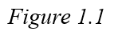

This project utilizes the Windkessel model to calculate various cardiovascular parameters for three different patients. Key metrics analyzed include cardiac output (CO, in L/min), stroke volume (SV, in mL/beat), and vascular resistance (R, in mmHg·min/L). Additionally, the effect of varying resistance on these parameters is explored.

The results of the present study will be used to improve our knowledge on the applicability and limits of the Windkessel model under different physiological conditions and in age groups. What makes the data so exciting is that, by taking a comprehensive look at how things change from childhood to middle age to older adulthood, we hope it can help us develop more refined cardiovascular models than those now in use. Additionally, these advances can ultimately lead to increased accuracy of diagnosis and tailored therapeutic approaches in the clinic.

# MATERIALS AND METHODS

# **Materials**

To analyze this model, we apply the analogy between hydraulic and electrical systems. Specifically,

we refer to the model shown in Figure 2.1, which includes the following components:

-**Proximal resistance (R1)**: represents the resistance in the proximal part of the aorta.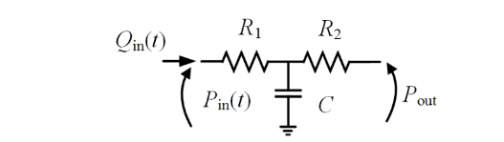

-**Capacitance (C)**: models the compliance of the arterial system, which reflects the ability of the arteries to stretch and store blood.

- **Distal resistance (R2)**: represents the peripheral resistance, 

-**Asymptotic pressure (Pout)**: models the long-term steady-state pressure in the system.

The figure also includes:

-**Qin(t)**: the volumetric flow rate (in m³/s or ml/s), representing the amount of blood flowing through the system over time.

-**Pin(t)**: the pressure (in Pa or mmHg) at the proximal aorta, indicating the pressure at the entrance to the arterial system.

This hydraulic model is analogous to an electrical circuit, where resistances correspond to blood

flow resistance, and capacitance represents the elasticity or compliance of the arterial walls.

For this project, we used MATLAB to simulate the arterial pressure response. We worked with data from three different patients, each providing paired blood flow (Q) and pressure (P) values, along with the corresponding parameters: proximal resistance (R1), distal resistance (R2), total arterial compliance (C), and outflow pressure (Pout). MATLAB was used to apply the 3-element Windkessel model and analyze how pressure behaves based on these inputs.

## 

## Analyzing the data

With this data we analyzed each of the patient's cardiac output (CO) in liters per minute, their stroke volume (SV) in mL/ beat and their vascular resistance (R) in mmHg·min/L. In order to calculate this we used the following equations, Eq (1), Eq(2) and Eq(3).:

(1)

(2)

(3)

## Plotting

In the next section, for each (P, Q) pair, we used MATLAB to analyze the 3-element Windkessel (3-WK) model. By setting the blood flow rate (Q), we calculated the corresponding pressure (P3-WK) using the model. We then compared this simulated pressure to the measured or generated pressure (Pmeas) to see how closely they matched. Since the pressure response should be periodic, we made sure the simulated pressure followed this pattern. MATLAB was also used to plot both the simulated and measured pressures for easy comparison.

We first set up a constant (cte_04) and extended the flow rate (Q) and pressure (P) data over several cycles to create periodic inputs (QQ_04, PP_04). Next, we generated a time vector (tt_04)with small intervals (0.001 seconds).

After this we calculated the input pressure (Pin_04) by applying an exponential decay based on the parameters R2_04 and C_04, while adding contributions from flow (Q) and outflow pressure (Pout_04). Inside a loop, we solved the integral from Eq4:

(4)

Finally, we plotted the simulated pressure (Pin_04) against the measured pressure (PP_04) for comparison.

## Errors

To see how well the model represents reality, we calculated four types of errors: the average point-to-point relative error, the error in mean pressure, and the errors in systolic and diastolic pressures. These error calculations, based on the work of Boileau et al. (2015), helped us determine how accurate the 3-WK model is in reflecting actual conditions, in particular we have:

* Eq 5 shows the **point to point average error**,
* Eq 6 represents the **error in the mean value**,
* Eq 7 and Eq 8 describe the **error in systolic and diastolic value** respectively:

(5)

(6)

(7)

(8)

# Analysis of the influence of the distal resistance ()

In order to analyze how the distal resistance altered the 3-element Windkessel (3-WK) model we repeated the same process as before calculating the simulated pressure. However, this time we adjusted R2 by increasing it by 25% and then decreasing it by 25%, and ran the simulation for each modified value. By plotting and comparing the results, we could observe how these changes in R2 impacted the pressure response.

# RESULT

* 1. **Analyzing data**

Based on the calculations made in the first section, we obtained the values shown in the Figure 3.1. Notably, there is a substantial difference between the first patient (number 4) and the other two (number 5 and 6): the first patient exhibits lower stroke volume and cardiac output values, along with higher resistance.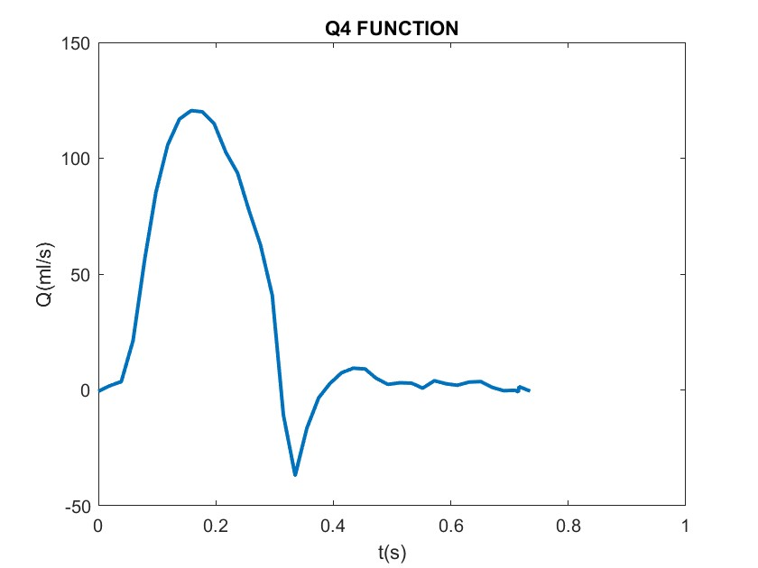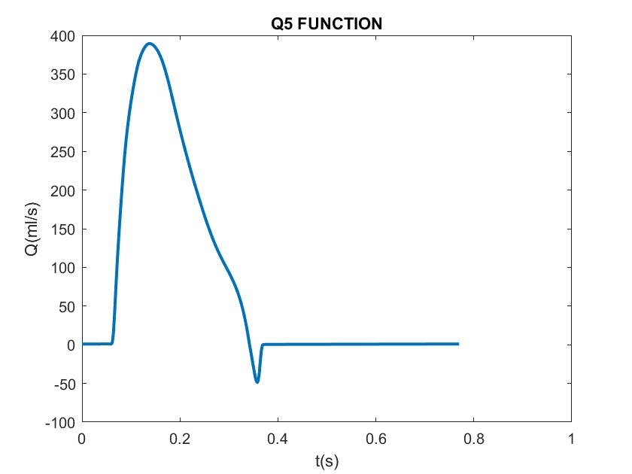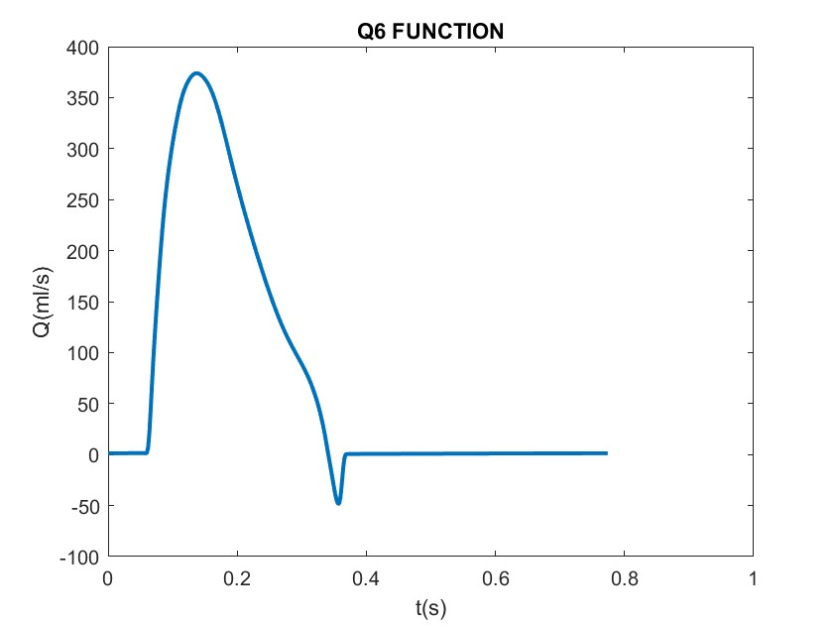

*Figure 3.1: Graphs of Q for each of the patients*

SV4 = 0.022004 SV5 = 0.0617 SV6 = 0.059374

CO4 = 1.7963 CO5 = 4.6126 CO6 = 1.7817

R_04 = 28.7195 R_05 = 20.0874 R_06 = 20.2367

* 1. **Plotting**

In our pressure calculation, we implemented a loop and extracted the final cycle to generate the pressure graph. This enables us to compare it with the corresponding data graph. As a result, we obtained the following graphs for the three patients (in blue is the simulated pressure, in red the data):

*Figure 3.2: Graphs comparing the real and simulated pressures of each of the patients.*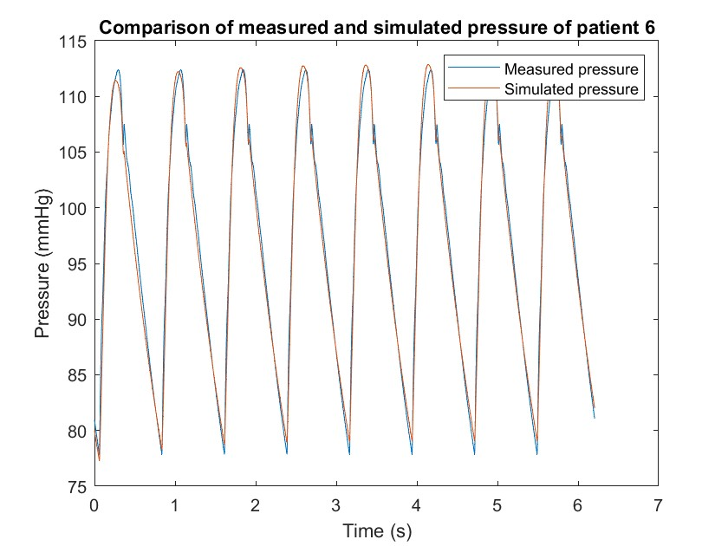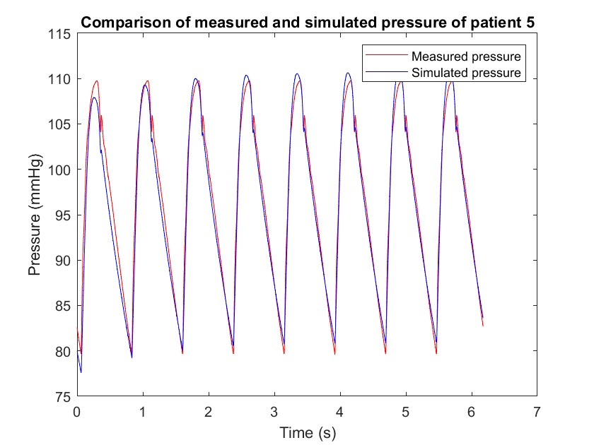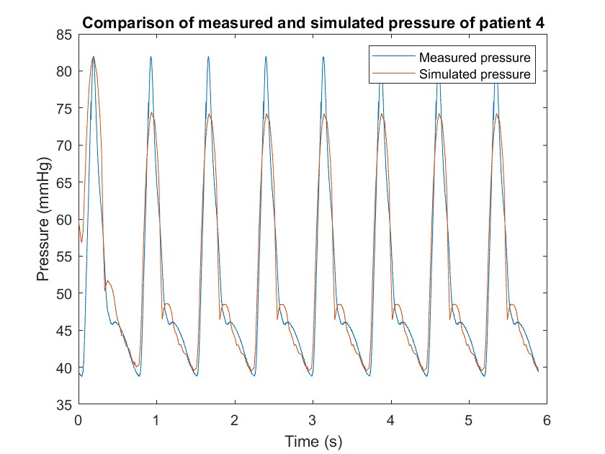

Observing the graphs we realized the first pulse couldn’t be considered a whole as it didn’t start or end in the same place. That’s why we chose to keep the last pulse of each graph to calculate everything:

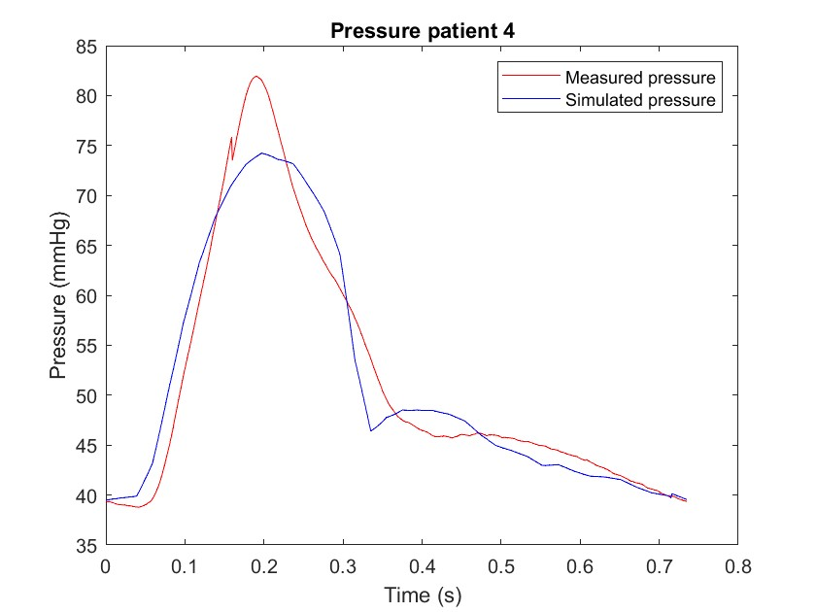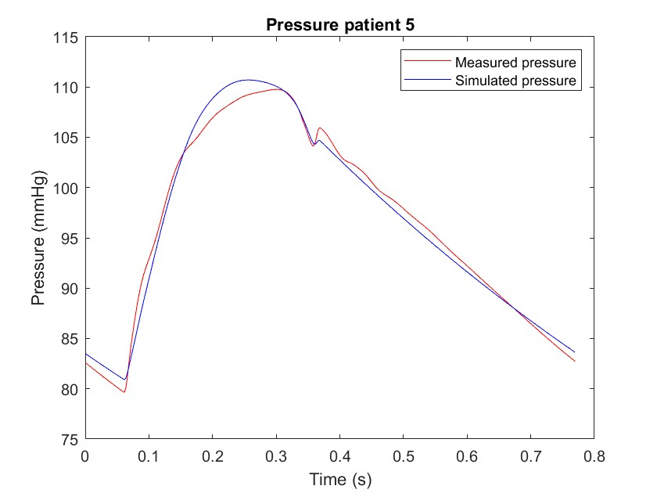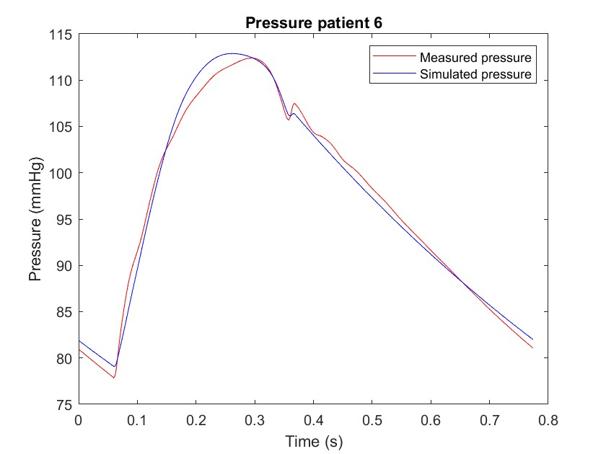

*Figure 3.2.1: Graphs comparing the real and simulated pressures of each of the patients only for one pulse.*

* + 1. **Errors**

Utilizing the formulas presented earlier, we calculated the individual errors for each patient, resulting in the following values:

*Table 1: The errors calculated for each patient. (Eq 5, Eq , Eq7 and Eq8)*

| Patient # |  |  |  |  |
| --- | --- | --- | --- | --- |
| 4 | 0.20164% | 0.0011414% | 9.3866% | 1.8697% |
| 5 | 0.055665% | -0.013918% | 0.84972% | 1.5811% |
| 6 | 0.05695% | 0.0025621% | 0.44001% | 1.5812% |

# Analysis of the influence of the distal resistance ()

In the last analysis, we examined the pressure values by increasing and decreasing the resistance R2. In particular we increase the peripheral resistance by 25% and decrease it by 25%. The results obtained are illustrated in the following graphs:

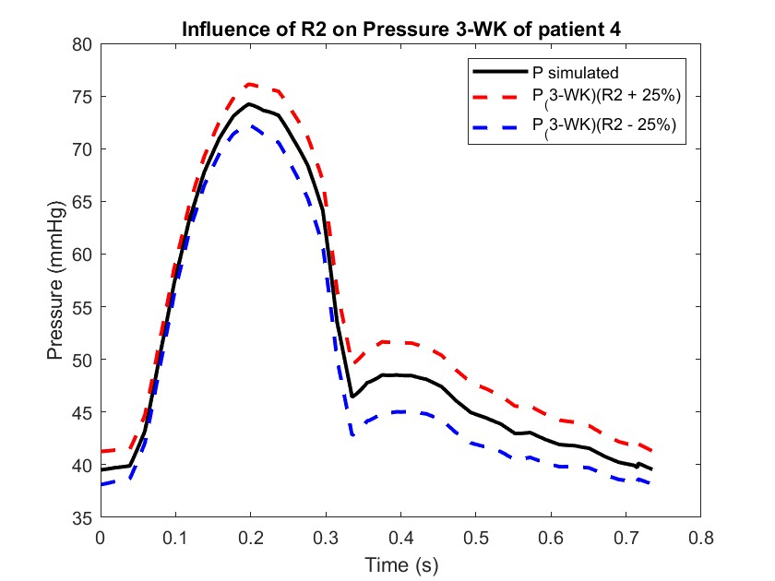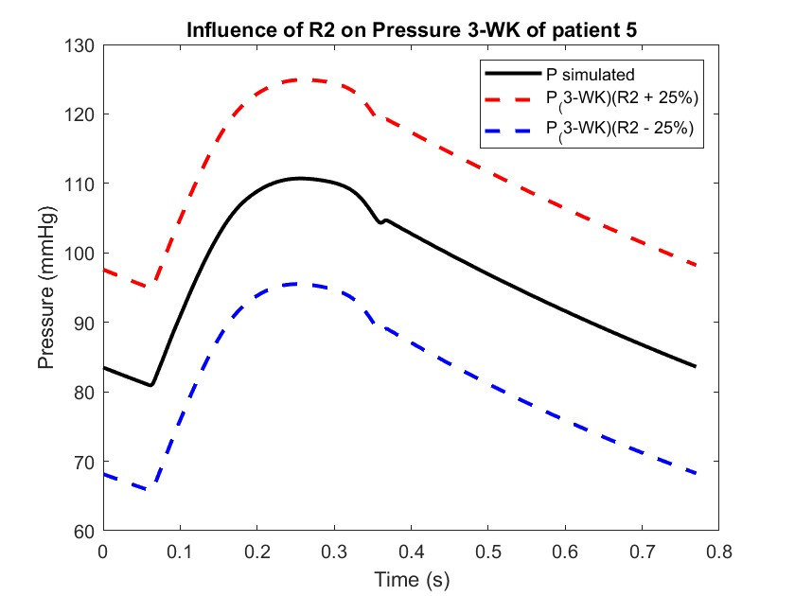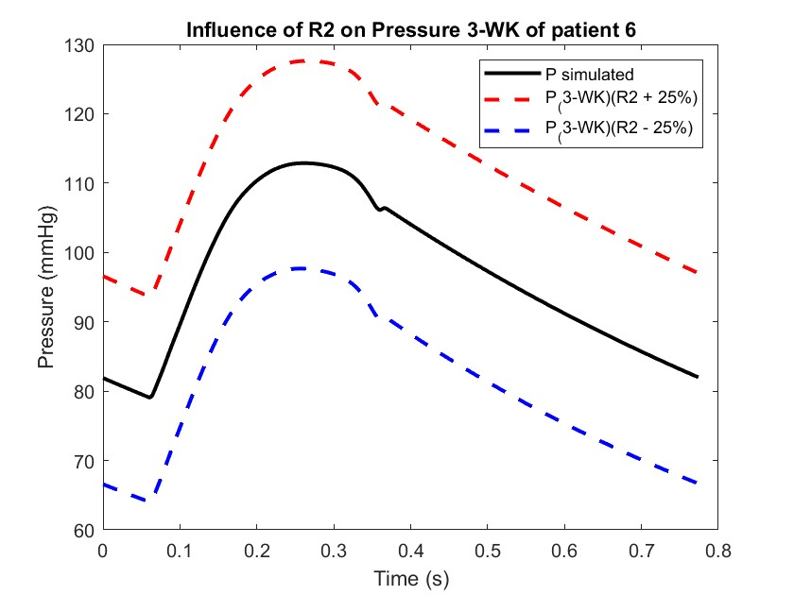

*Figure 3.3: Graphs comparing the real and simulated pressures of each of the patients.*

# DISCUSSION

From this research of three patients it can be stated that the first patient has a significantly reduced stroke volume and cardiac output associated with increased peripheral resistance. The stroke volumes and cardiac outputs of the other two patients appear to be within a normal physiological range in contrast. From this, we can say that the first patient is a child and hence, the second and third patient are middle aged. This conclusion is based on the idea that children have an immature Cardiovascular system and this leads to reduced Cardiac output and increased peripheral resistance. We might expect to see higher values in the raw data of patients five and six since they likely have more mature cardiovascular systems; hence a small difference between those two reflecting age-related or biological variations. Second, we also see that the error in all the previous computations had a very low significance according to our result. Almost all the absolute errors have values under 2%. This shows that the model is useful for an adequate description of the cardiovascular system.

In the third part of the project we analyze the influence of R2 changing it slightly (+/- 25%).

The obtained results lead us to conclude an increase in the resistance R2​ (3-WK) would cause the following changes:

* When peripheral resistance of the arterial system increases it presents a higher difficulty for blood to flow through small arteries and capillaries.
* A study in this case of the time varying response of a specific form of a simple reaction diffusion model was used to show that higher arterial pressure (larger R2​) will lead to an increased arterial blood pressure for the same flow Qin(t) due to the fact that the heart has to pump against more resistance.[5]

On the other hand, by decreasing R2​, we observe the following​:

* When the peripheral resistance is reduced, it represents a situation where it is easier for blood to flow through the arterial system.
* Reduced arterial pressure: a lower resistance means the heart exerts less pressure to maintain blood flow, resulting in a decrease in arterial pressure.

This captures the relationship between resistance and the cardiovascular dynamics in the Windkessel model clearly and concisely.

# REFERENCES

1. Catanho, Sinha and Vijayan. (2012) Model of aortic blood flow using the Windkessel effect.

2. Capoccia, M. (2015) PhD Thesis: Development and characterization of the arterial Windkessel and its role during left ventricular assist device assistance. *Artificial Organs*, 39(8).

3. Tricarico, R., Berceli, S. A., Tran-Son-Tay, R., & He, Y. (2023). Non-invasive estimation of the parameters of a three-element Windkessel model of aortic arch arteries in patients undergoing thoracic endovascular aortic repair. *Frontiers in bioengineering and biotechnology*, 11.

4. Boileau, E., Nithiarasu, P., Blanco, P. J., Müller, L. O., Fossan, F. E., Hellevik, L. R., Donders, W. P., Huberts, W., Willemet, M., & Alastruey, J. (2015). A benchmark study of numerical schemes for one-dimensional arterial blood flow modeling. *International Journal for Numerical Methods in Biomedical Engineering*, 31(10).

5. Westerhof, N., Lankhaar, J.-W., & Westerhof, B. E. (2008). The arterial Windkessel. Medical & Biological Engineering & Computing, 47(2), 131–141.